**MICROPROCESSOR AND INTERFACING TECHNIQUES**

**CODE: CSI2006 SLOT: L53 + L54**

**LAB ASSIGNMENT – 4**



**AIM:** To write an assembly language program for

* Reversing a string
* Block transfer

**ALGORITHM:**

* Reversing a string

**Input:**

-> “das” as input

**Process:**

* Using a stack to store the string via using push().
* Then popping out the string and as the stack stores the in LIFO manner hence our string is reversed.

**Conclusion for reversing the string:** String in the reverse manner as output

**For displaying time:**

**ALGORITHM:**

**Input:**

**Process:**

**Conclusion for 2nd programme:**

**TEAM MEMBERS:**

* Saksham Verma (19MID0023)
* Tharun S (19MID0031)
* Sabarinathan R V (19MID0057)
* Motishwaran C (19MID0017)
* Prashanth S (19MID0020)

ALP for sorting elements in ascending order using bubble sort.

**CODE:**

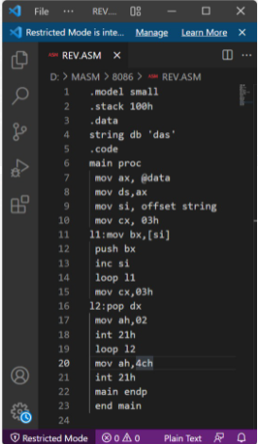

.model small

.stack 100h

.data

string db 'das'

.code

main proc

mov ax, @data

mov ds,ax

mov si, offset string

mov cx, 03h

l1:mov bx,[si]

push bx

inc si

loop l1

mov cx,03h

l2:pop dx

mov ah,02

int 21h

loop l2

mov ah,4ch

int 21h

main endp

end main

**OUTPUT:**

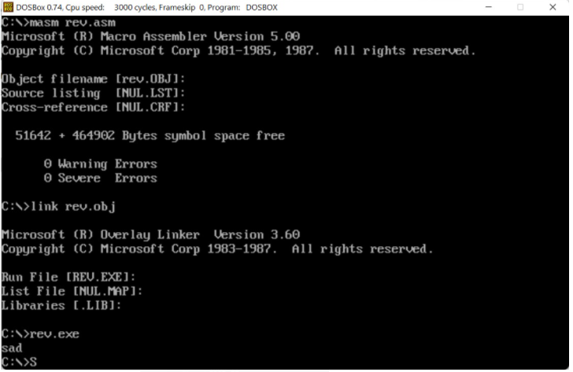

ALP for sorting elements in ascending order using bubble sort.

**CODE:**

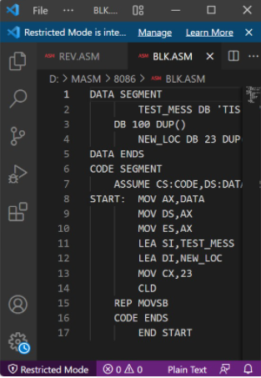

DATA SEGMENT

TEST_MESS DB 'TIS TIME FOR A NEW HOME'

DB 100 DUP()

NEW_LOC DB 23 DUP(0)

DATA ENDS

CODE SEGMENT

ASSUME CS:CODE,DS:DATA,ES:DATA

START: MOV AX,DATA

MOV DS,AX

MOV ES,AX

LEA SI,TEST_MESS

LEA DI,NEW_LOC

MOV CX,23

CLD

REP MOVSB

CODE ENDS

END START

**OUTPUT:**

